A Modified Attention-PestNet with Channel-Reduced Hierarchical Scaled Dot-Product Attention for
Efficient Insect Pest Detection

Lean Adrian Murillo
BS in Computer Science
University of Mindanao
Matina, Davao City, 8000
l.murillo.546842@umindanao.edu.ph
James Oliver C. Mendoza
BS in Computer Science
University of Mindanao
Matina, Davao City, 8000
j.mendoza.545461@umindanao.edu.ph

Charisse P. Barbosa
University of Mindanao
Matina, Davao City, 8000
charisbarbosa@umindanao.edu.ph

DM Rashid P. Ferrer
BS in Computer Science
University of Mindanao
Matina, Davao City, 8000
d.ferrer.5454581@umindanao.edu.ph
CCS Concepts
CCS → Computing methodologies → Artificial intelligence → Computer vision → Computer vision problems → Object detection

General Terms
Algorithms, Performance, Experimentation, Documentation

Keywords
Attention-PestNet; CR-HSDPA; Insect Pest Detection; Channel Reduction; Object Detection

INTRODUCTION

Background of the Study
Plant pests remain a major agricultural and food-security concern. The Food and Agriculture Organization of the United Nations (FAO) estimates that between 20% and 40% of global crop production is lost to pests each year, with plant diseases costing the global economy around USD 220 billion and invasive insects around USD 70 billion annually [1]. These losses reduce crop availability and farm income, and they limit the ability of producers to respond quickly to outbreaks.

In the Philippines, the scale of crop production makes timely monitoring particularly important. National palay production reached 19.67 million metric tons in 2025 from approximately 4.75 million hectares of harvested area [2]. Philippine agriculture is composed largely of small-scale, low-technology producers, and modernization, innovation, and digital technology are identified as important parts of its transformation [3]. Consistent with this, the Department of Agriculture has adopted digitalization as a strategy for more science- and information-driven decision making [4]. Digital tools are especially useful where expert inspection is not continuously available, because manual and expert-guided pest identification is labor-intensive, time-consuming, and difficult to scale [5].

The need for reliable monitoring is heightened by the pest pressure on Philippine farms. Farms in the country averaged only 0.83 hectares in 2022 [6], so many small fields must be watched by a limited number of farmers and technicians. Using Bureau of Plant Industry data from 2021 to 2025, DA-PhilRice identified brown planthoppers, rice stemborers, rodents, bacterial leaf blight, and leaffolders as the top threats to rice crops in early 2026 [7]. Climate change may worsen this situation: an FAO-supported scientific review reports an increasing risk of pest spread under climate change, with pests such as the fall armyworm already spreading because of warmer conditions [8]. Philippine agencies are likewise promoting climate-smart pest management because pest threats are being worsened by climate change [9]. Frequent, consistent field monitoring is therefore essential, and it is difficult to sustain by manual inspection alone.

Computer-vision models can complement manual inspection by recognizing insect pests from field images in a repeatable, automated way. Deep-learning detectors learn hierarchical features directly from image data and are increasingly used for pest monitoring, with one-stage detectors favored where prediction time is critical [5]. However, practical use does not depend on accuracy alone. Reviews of deep learning for plant pest detection note that model complexity and computational requirements are barriers to deployment where resources are limited, and that many small-scale farms lack the infrastructure and hardware to run complex models [10]. High-capacity models, including transformer-based ones, are reported to offer strong accuracy but to require considerable resources, which makes them impractical on edge or mobile devices used in the field [11]. Models intended for wider agricultural deployment must therefore also control computational cost, memory consumption, and inference latency.

Attention-PestNet, proposed by Doan et al. [5], is a one-stage insect-pest detector that combines Multi-Scale Spatial Attention (MSPA), Tri-Directional Attention (TDA), and Hierarchical Scaled Dot-Product Attention (HSDPA). On IP102, the main comparative experiment reported 68.67% mAP@50 and 44.17% mAP@50:95, while the selected large configuration requires about 79.6 million parameters and 162.7 GFLOPs. In the same comparison, YOLOv8-L reached 66.86% mAP@50 with 43.7 million parameters, and YOLOv9-C reached 66.07% with 25.6 million parameters and 104.0 GFLOPs. The accuracy gain therefore comes with a substantially larger model. The authors explicitly identify model complexity and resource usage as an area for improvement, noting that repeated attention modules may limit deployment on constrained hardware and suggesting lighter variants with fewer redundant attention layers [5].

The baseline authors identify repeated attention processing and resource usage as limitations. This study proposes channel reduction within HSDPA as a way to investigate that broader complexity problem; the baseline authors did not specifically propose this bottleneck. The modified module is called Channel-Reduced Hierarchical Scaled Dot-Product Attention (CR-HSDPA). The proposed module introduces a learnable 1×1 channel-reduction bottleneck before the hierarchical TDA operations so that attention is performed on a compressed feature representation. Unlike the baseline model-size variants that adjust network-wide width and depth, CR-HSDPA specifically targets the internal computation of HSDPA while retaining the four hierarchical TDA levels selected by the baseline study. The study aims to reduce model complexity while measuring the resulting change in detection performance against a faithful Attention-PestNet reimplementation using the verified public dataset releases. The proposed model will be evaluated on IP102, a large multi-crop pest benchmark that includes rice among its field crops, and R2000, a benchmark focused exclusively on rice pests [5].

Table 1. Related Literature
Baseline Studies | Results | Findings/Gaps
Doan et al. [5] | Attention-PesNet achieved 68.67% mAP@50 and 44.17% mAP@50:95 on IP102; about 79.6M parameters and 162.7 GFLOPs. | The study found that Multi-Scale Spatial Attention (MSPA) and Hierarchical Scaled Dot-Product Attention (HSDPA) improve pest detection by combining multi-scale spatial cues with long-range contextual information. Four hierarchical attention levels provided the strongest reported accuracy-efficiency balance, while deeper configurations produced diminishing returns. However, the authors also identify the repeated attention modules as a source of computational complexity and recommend lightweight variants, removal of redundant attention layers, and more efficient attention/transformer components for future work.
Zhang et al. [12] | C3M-YOLO: 57.2% mAP@50, 38.5% mAP@0.75; 7.12M parameters, 16.1 GFLOPs, 97 FPS. | The lightweight C3M module reduced computational demand and improved inference efficiency, while the Global Attention Mechanism further improved pest detection performance on IP102. The results support the use of compact modules for pest detection; however, the model does not address the Hierarchical Scaled Dot-Product Attention (HSDPA) structure used by Attention-PestNet, leaving the baseline's attention-specific complexity unresolved.
Dong et al. [13] | PestLite on IP102: 57.1% mAP@50 with 6.34M parameters and 16.3 GFLOPs. | PestLite demonstrated that lightweight feature extraction, attention, and feature-fusion modules can support real-time crop pest detection with a compact YOLO-based design. Its findings show the feasibility of reducing model size for agricultural detection, but the architecture is different from Attention-PestNet and does not evaluate a lighter redesign of HSDPA.
Liu et al. [14] | EfficientViT reports higher throughput and improved accuracy over several mobile vision models using Cascaded Group Attention. | EfficientViT found that memory-inefficient operations and highly similar attention maps across heads can create redundant computation in conventional multi-head self-attention. Cascaded Group Attention reduces this redundancy while preserving a strong speed-accuracy trade-off. The work is designed for general efficient vision models, so its lightweight-attention findings still require validation within an insect-pest detector such as Attention-PestNet.
Wang et al. [15] | LiteFocus-YOLO (2025): 97.9% mAP@50 on UAVMaize; 94.6% on FusionMaize and 95.7% on Wheat Ear. The model reports 7.9M parameters and 27.4 GFLOPs in its cross-dataset evaluation. | LiteFocus-YOLO introduces a Lightweight Target-Aware Attention Module (LTAM) that uses 1×1 convolutions with a channel-compression ratio to reduce the channel width to C/r and then restore it. The authors report that the reduction ratio controls the trade-off between lightweight computation and feature loss. This provides recent agricultural-object-detection evidence that learnable channel compression can be used inside an attention-oriented module. However, it was not evaluated within the hierarchical TDA-based HSDPA of Attention-PestNet.
Yang et al. [16] | YOLO-RP on the authors' rice-pest dataset: 90.99% mAP@50, 1.00M parameters, 3.1 GFLOPs, 2.8 MB; 20.8 FPS on Jetson Nano. | YOLO-RP showed that structural simplification and lightweight feature-processing modules can substantially reduce parameters, GFLOPs, and model size while retaining strong rice-pest detection performance. Its 90.99% mAP@50 result is from a different rice-pest dataset. Cross-dataset experiments still support the feasibility of lightweight pest detectors.

The reviewed studies indicate that lightweight pest detection can be achieved by reducing redundant computation, compressing feature representations, or replacing expensive operations with more efficient alternatives. EfficientViT shows that redundant computation within attention can be reduced [14], while LiteFocus-YOLO applies learnable 1×1 channel compression with an explicit reduction ratio inside an attention-oriented module for agricultural object detection [15]. Together, these findings motivate an investigation of whether channel compression can reduce computation within HSDPA while retaining its selected four-level attention hierarchy. In addition, the baseline describes TDA complexity as O(HWC²); reducing the attention width from C to C_r suggests that the channel-dependent attention term should decrease as C_r becomes smaller, while the added projection cost must still be measured empirically through total-model GFLOPs and runtime metrics [5].

The baseline HSDPA ablation also shows diminishing returns as hierarchical depth increases. The reported two-, three-, and four-level configurations require 134.86, 148.66, and 162.76 GFLOPs, respectively, while mAP@50 rises from 68.5% to 69.0% and 69.7%. Increasing the hierarchy to five and six levels raises computation further while reducing mAP@50 [5]. Although the baseline examined different hierarchical depths, the present study holds the selected four-level hierarchy constant so that the effect of channel reduction can be examined separately.

  - Purpose and Description
This study aims to develop and evaluate a Channel-Reduced Hierarchical Scaled Dot-Product Attention (CR-HSDPA) module to reduce the computational cost of Attention-PestNet for insect pest detection while maintaining detection performance close to the reproduced baseline [5]. The study addresses the computational requirements of repeated hierarchical attention by investigating whether channel reduction can improve architecture-level computational efficiency, with potential relevance to resource-constrained deployment. It also supports Sustainable Development Goal 2, Zero Hunger, particularly Target 2.4 on sustainable and resilient agricultural production [17]. However, actual deployment on agricultural edge devices is outside the scope of the study.

The proposed model replaces the three HSDPA blocks in the Attention-PestNet neck with CR-HSDPA. Each CR-HSDPA block introduces a learnable 1×1 channel-reduction projection that reduces the incoming channel dimension from C to C_r, where C_r is obtained from the tested ratio r using a deterministic implementation-compatible rounding rule. The four TDA levels are retained so that channel reduction remains the primary architectural variable, and a restoration projection returns the feature representation to the required output channel dimension C after attention processing. The backbone, SPPF, PANet-style feature-fusion path, and detection head remain unchanged. The faithful Attention-PestNet reimplementation and CR-HSDPA variants will be trained and evaluated separately on IP102 and R2000 using identical dataset partitions, training configurations, and the same Kaggle NVIDIA T4 GPU environment. Performance will be measured using mAP@50 and mAP@50:95, while computational efficiency will be assessed through parameter count, GFLOPs, model size, FPS, and inference latency.

  - Objectives
    - General Objective
To modify and evaluate a lightweight variant of Attention-PestNet by introducing a Channel-Reduced Hierarchical Scaled Dot-Product Attention (CR-HSDPA) module that reduces the computational complexity of hierarchical attention while maintaining comparable insect-pest detection performance.

    - Specific Objectives
      - Reproduce the Attention-PestNet baseline on IP102 and R2000 and establish reference values for its detection performance and computational efficiency on the available hardware.
      - Design CR-HSDPA by introducing a learnable pre-attention channel-reduction bottleneck while retaining the original four-level TDA hierarchy and keeping the remaining Attention-PestNet components unchanged.
      - Conduct ablation experiments to determine the effect of different CR-HSDPA channel-reduction ratios on mAP@50, mAP@50:95, number of parameters, GFLOPs, model size, FPS, and inference latency while keeping the original four-level TDA hierarchy and other Attention-PestNet components unchanged.
      - Assess the selected CR-HSDPA configuration in terms of detection performance and computational efficiency relative to the reproduced Attention-PestNet baseline using mAP@50, mAP@50:95, number of parameters, GFLOPs, model size, FPS, and inference latency.

  - Scope and Limitations
The study focuses on architectural lightweighting of Attention-PestNet for insect-pest object detection. Both IP102 and R2000 are used as benchmark datasets, and the experiments retain the baseline input resolution of 640×640 pixels and the same overall backbone-neck-head structure. IP102 provides the broader multi-crop benchmark, while R2000 provides a secondary rice-pest-focused benchmark. R2000 was constructed with reference to the rice-pest data and characteristics of IP102, but its public release is a separately collected rice-pest dataset rather than a direct image subset of IP102 [19], [20]. The two datasets will therefore be treated as related same-domain benchmarks rather than evidence of external-domain generalization. The work is limited to the complexity-and-deployment gap identified by the baseline authors; the separate issues of dense small-pest failure cases and multimodal RGB-thermal-hyperspectral fusion are outside the scope of this study. Dataset-version discrepancies identified in IP102 and R2000 are documented transparently; only verified annotated samples are used, and no images are added or duplicated to match conflicting published totals.

Training and inference will be performed on an NVIDIA T4 GPU provided through Kaggle rather than the RTX 4090 used by the baseline paper. Therefore, FPS and latency values reported by the original paper will not be directly compared with measurements from this study. Instead, both the reproduced baseline and the proposed model will be measured in the same Kaggle T4 GPU environment. Parameter count and GFLOPs will be reported as architecture-level metrics, while hardware-dependent measurements will be interpreted only within the test environment. Actual deployment on a Jetson, Raspberry Pi accelerator, or other edge platform is outside the present scope.

METHODS
The study follows the methodology below to accomplish the general objective:
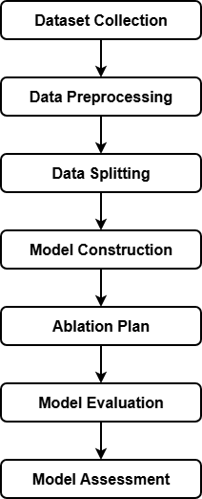

Figure 1. Methods model

Figure 1 shows the methodology of the study which starts from dataset collection, preprocessing and splitting. It is then followed by model construction, training configuration, ablation plan, model evaluation and model assessment.

Dataset Collection

Dataset Description
The study uses the IP102 and R2000 object-detection benchmarks evaluated by Attention-PestNet. IP102 contains 75,222 RGB images across 102 pest categories, with a bounding-box-annotated subset used for detection [5], [18]. R2000 is a 16-class rice-pest detection dataset derived from IP102 and is used as a smaller, rice-focused benchmark [5], [19], [20].

Dataset Consistency and Reproducibility
Two reporting inconsistencies were identified during dataset verification. For IP102, Attention-PestNet reports 18,983 detection images, but its stated split of 15,178 training and 3,798 testing images totals 18,976. Inspection of the downloaded release likewise found 18,976 XML bounding-box annotations with matching images; five additional JPG files lack XML annotations, while seven TXT files in the annotation directory are not XML bounding-box annotations. Accordingly, this study uses 18,976 as the usable annotated IP102 detection set and retains 18,983 as a documented inconsistency in the baseline paper [5].

R2000 presents a similar version inconsistency. Attention-PestNet reports 2,046 images, a 60/15/25 split into 1,225 training, 298 validation, and 523 testing samples [5], whereas earlier R2000 literature and Paddy-YOLO report 2,024 images across 16 classes [19], [20]. The downloaded R2000v1 archive likewise contains 2,024 JPG images with 2,024 YOLO-format annotations. This study therefore uses the public 2,024-image version and does not add or duplicate samples to reach 2,046. If the exact Attention-PestNet partition cannot be recovered, the R2000 split used here will be identified as a recreated split.

  - Data Preprocessing

Resizing and Annotation Handling
Input images from both IP102 and R2000 will be prepared at 640×640 pixels to match the Attention-PestNet training configuration [5]. Bounding-box annotations and class labels will be preserved using the format expected by the released Ultralytics-based implementation. The released baseline code will be checked for its resize or letterbox method, normalization, annotation conversion, and training
augmentations. Their exact settings and code revision will
be recorded before training and applied identically to the reproduced baseline and all CR-HSDPA variants.

Data Splitting
    - Dataset Split Configuration
For IP102, the study follows the operational split reported by Attention-PestNet: 15,178 training images and 3,798 testing images, totaling 18,976 annotated samples [5]. For R2000, the reported 1,225/298/523 split cannot be assumed to correspond to the verified 2,024-image public archive because those counts total 2,046. Unless the exact 2,024-image assignment is recovered from the source release, a reproducible train/validation/test split will be generated from the verified archive using a fixed seed and documented explicitly as a recreated split. The same partitions will be used for both the baseline Attention-PestNet and all CR-HSDPA variants.

Model Construction

Baseline Attention-PestNet Architecture

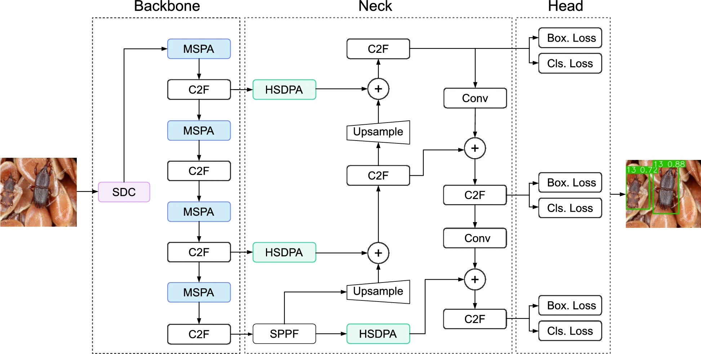
Figure 2. Baseline Attention-PestNet Architecture

Figure 2 shows Attention-PestNet follows a three-stage backbone-neck-head detector. The backbone begins with Spatial Downsampling Convolution (SDC), which reduces spatial resolution while extracting low-level visual information. Alternating Multi-Scale Spatial Attention (MSPA) and C2f blocks then refine spatial information at progressively deeper feature levels. MSPA combines directional spatial attention with multi-scale pooling, allowing the backbone to preserve both fine and broader contextual features useful for pests that differ in size and appearance [5].

The neck performs PANet-style multi-scale feature fusion. Feature maps from the backbone are processed through HSDPA modules, upsampled, and combined with features from other levels before further C2f refinement. HSDPA is built from Tri-Directional Attention (TDA), which models height-, width-, and channel-wise relationships. Multiple TDA blocks are arranged hierarchically, and their intermediate outputs are combined with the input before a 1×1 convolution refines the aggregated feature representation. The selected baseline configuration uses four hierarchical TDA levels [5].

The head receives three fused feature scales and performs the final bounding-box and class predictions. This design allows the network to combine detailed spatial information from shallower layers with stronger semantic information from deeper layers. In this study, this complete baseline is reproduced first so that all proposed changes can be measured against the same implementation and hardware environment.

      - Spatial Downsampling Convolution
The Spatial Downsampling Convolution (SDC) module serves as the foundational stem layer within the backbone of the baseline Attention-PestNet architecture [5]. Located at the entry stage of the feature extraction pipeline, SDC operates directly on the raw high-resolution input image (640 × 640 × 3 pixels) to accomplish two primary objectives: performing early spatial resolution reduction and extracting essential low-level visual primitives, such as edges, boundary contours, and basic color variations [5]. In agricultural object detection, insect pests are often photographed against cluttered plant canopies, soil backgrounds, and irregular field illumination [5], [21]. Under these field conditions, the stem block must extract discriminative boundary cues while avoiding excessive memory consumption and computational latency during high-resolution spatial processing [5].

Inspired by the initial convolutional downsampling design of ResNet-18, the SDC module is constructed as a two-layer convolutional pipeline that intentionally excludes residual connections, channel partitioning, and multi-branch structures [5]. Given an input tensor X ∈ ℝ^{3 × H × W}, where H = W = 640, the first layer executes a 3 × 3 standard convolution with a stride of 2 and a padding of 1. This downsamples the spatial dimensions by half to (H/2) × (W/2) (320 × 320 pixels) while expanding the feature depth to the initial backbone channel dimension C_1. The convolution is succeeded by Batch Normalization (BN) and the Sigmoid Linear Unit (SiLU) activation function:

To further refine feature representations without reducing spatial resolution further, the intermediate representation X_1 is passed through a second 3 × 3 standard convolution configured with a stride of 1 and a padding of 1, likewise followed by Batch Normalization and SiLU activation:

This two-step design stabilizes early gradient propagation and enhances non-linear representational capacity while preserving fine localized pest cues [5]. In comparison to the standard Conv stem employed in conventional YOLO architectures or complex downsampling modules such as ADown (which partitions channels and combines parallel max-pooling branches), SDC avoids branching overhead and channel splitting [5]. In agricultural pest detection, where insects frequently occupy very small pixel areas, overly aggressive multi-branch pooling in early layers can dilute fragile edge boundaries and impose substantial memory access costs on hardware [5], [21]. The streamlined sequential topology of SDC ensures computationally lightweight feature extraction while providing stable feature representations to the subsequent backbone stages [5].

      - Multi-Scale Spatial Attention
The Multi-Scale Spatial Attention (MSPA) module is embedded across multiple backbone stages, alternating with Cross-Stage Partial with Fusion (C2f) blocks to strengthen spatial feature representations [5]. Insect pest recognition in real agricultural settings faces two major computer vision challenges: extreme intra-species visual variation across metamorphosis life stages (e.g., eggs, larvae, pupae, and adults) and high inter-species visual similarity among morphologically related pest taxa [5], [21], [22]. Conventional spatial attention modules often utilize single-scale pooling kernels or collapse 2D spatial feature maps into scalar channel descriptors, which diminishes their ability to simultaneously isolate minute insect appendages and outline broad body contours [5], [22]. Drawing upon the principles of Coordinate Attention and Spatial Pyramid Pooling (SPP), MSPA resolves these limitations by integrating coordinate-aware directional global average pooling with a multi-scale spatial pooling pyramid [5], [21], [22].

The MSPA mechanism begins by executing directional global average pooling independently along the vertical and horizontal axes of the incoming feature tensor X ∈ ℝ^{C × H × W} [5]. Rather than condensing the entire spatial domain (H × W) into a single channel descriptor, two 1D spatial pooling kernels of dimensions H × 1 and 1 × W are utilized to encode positional coordinates along each spatial axis separately [5], [21]. Formally, the pooled output for the c-th channel at row height h ∈ [0, H - 1] is calculated as:

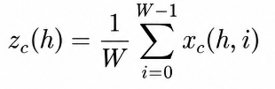

where x_c(h, i) denotes the activation value at row h and column i of the c-th channel, and W is the width of the feature map [5]. Simultaneously, the pooled output for the c-th channel at column width w ∈ [0, W - 1] is expressed as:

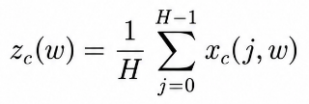

where H represents the height of the feature map [5]. These directional pooling vectors capture long-range contextual dependencies along one spatial axis while preserving precise spatial localization coordinates along the orthogonal axis [5], [21]. The input feature map X is subsequently modulated through element-wise multiplication with the directional attention features along both dimensions:

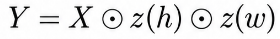

where Y ∈ ℝ^{C × H × W} is the directionally refined feature tensor, and ⊙ denotes element-wise multiplication [5]. This coordinate-sensitive reweighting emphasizes regions containing target insect bodies while attenuating background plant foliage [5], [21].
To further extract multi-scale spatial characteristics across varying pest body dimensions, the modulated tensor Y is processed through three parallel max-pooling layers configured with kernel sizes of 3 × 3, 7 × 7, and 13 × 13 [5]. Stride and padding parameters are configured to maintain spatial dimensional alignment across branches:

The fine-grained pooling branch (3 × 3) captures localized morphological markers, such as antennae, wing margins, and abdominal markings, which are vital for distinguishing species with high inter-class visual similarity [5], [21]. Concurrently, the larger pooling windows (7 × 7 and 13 × 13) encompass expanded receptive fields, capturing holistic body contours and aspect ratios that remain stable across developmental stages [5], [22]. The modulated feature map Y and the three pooled representations are concatenated along the channel dimension to form a composite multi-scale descriptor:

Finally, a 1 × 1 convolutional layer followed by Batch Normalization and SiLU activation reduces the concatenated channel dimension back to the target channel capacity C:

By jointly learning directional coordinate dependencies and multi-scale receptive field representations, MSPA enhances spatial discriminability, mitigates intra-species variability, and improves insect boundary localization prior to feature fusion [5].

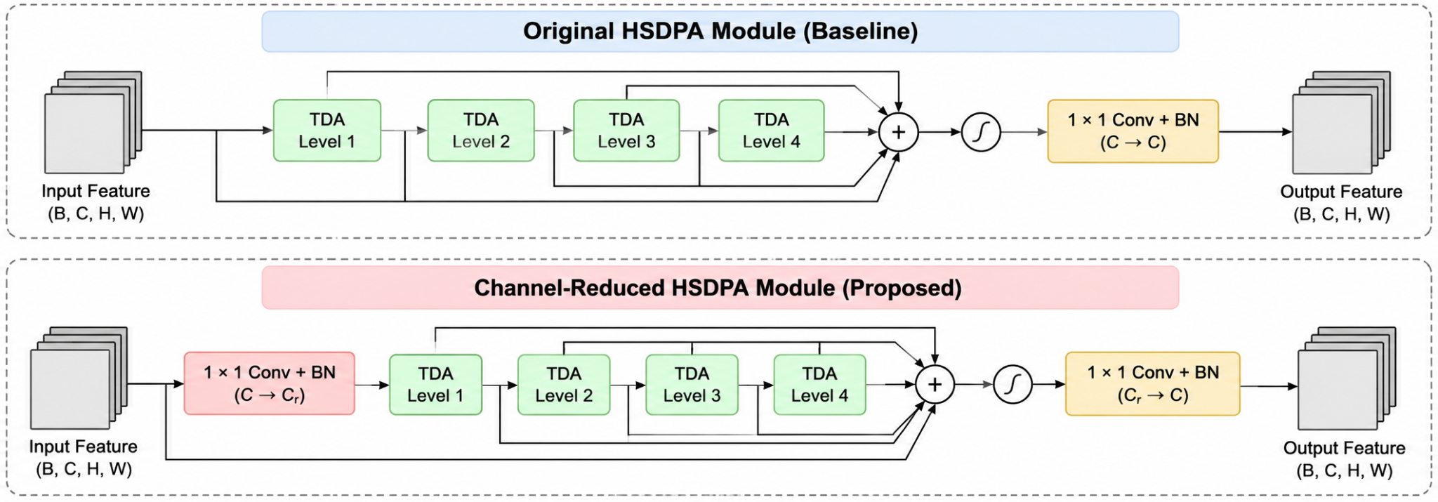
Figure 3. Original HSDPA Module

      - Hierarchical Scaled Dot-Product Attention
Figure 3 shows the Hierarchical Scaled Dot-Product Attention (HSDPA) module is deployed within the neck of Attention-PestNet, integrated directly into the Path Aggregation Network (PANet) multi-scale feature fusion topology [5]. In pest monitoring tasks, deep feature maps frequently suffer from ambiguous local textures and occlusions resulting from overlapping plant leaves [5], [10]. While standard multi-head self-attention mechanisms effectively model non-local semantic context across feature maps, their computational and memory complexity scales quadratically with spatial resolution (𝑂(H^2 W^2 C)), creating prohibitive memory overhead on high-resolution agricultural images [5]. To overcome this computational bottleneck, Doan et al. designed the Tri-Directional Attention (TDA) block as the core unit of HSDPA, factorizing scaled dot-product attention across height, width, and channel dimensions [5].

The TDA block extends the scaled dot-product attention formulation by decomposing full pairwise spatial interactions into three lightweight convolutional branches [5]. Given an input feature tensor X ∈ ℝ^{B × C × H × W}, where B represents batch size, C denotes channel depth, and H and W denote spatial height and width, three parallel convolutional projections generate direction-specific representations [5]. The height-wise branch produces a query feature map Q_h ∈ ℝ^{B × C × H × 1}, the width-wise branch produces a key feature map K_w ∈ ℝ^{B × C × 1 × W}, and the channel branch yields a value feature map V_c ∈ ℝ^{B × C × 1 × 1} [5]. Following reshaping and flattening across their corresponding dimensions, these tensors are represented as:

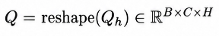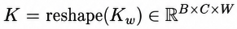

The spatial attention score matrix S is calculated via the dot product of the query and key representations, scaled by the spatial dimension factor d_k = H × W, and normalized using the Softmax function [5]:

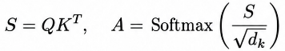

where Q, K ∈ ℝ^{B × C × (H × W)}. The normalized spatial attention matrix A is then multiplied with the channel-attention value vector V to produce the attention descriptor O = A V [5]. The final modulated feature representation Y_{TDA} is obtained through element-wise multiplication with the original input X:

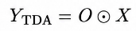

where ⊙ denotes element-wise multiplication [5]. Through this orthogonal directional decomposition, TDA reduces the theoretical computational complexity from 𝑂(H^2 W^2 C) to:

enabling long-range spatial and channel dependencies to be modeled effectively without prohibitive computational and memory demands [5].

To enrich contextual representation across multiple semantic abstraction depths, HSDPA stacks multiple TDA blocks hierarchically [5]. Rather than relying on isolated sequential layers that can cause gradient dissipation and early feature forgetting, HSDPA preserves intermediate representations generated at each hierarchical level [5]. In the baseline Attention-PestNet-L configuration, k = 4 hierarchical TDA levels are arranged in series [5]. The intermediate outputs from all k stages are concatenated together with the original input feature map X along the channel dimension:

A 1 × 1 convolutional layer followed by Batch Normalization then compresses the aggregated multi-level contextual features back to the nominal channel depth C:

This hierarchical design allows Attention-PestNet to integrate fine-grained spatial cues with deep semantic context, reinforcing stage-invariant and pose-invariant morphological features that help distinguish visually similar pests across complex backgrounds [5]. In the baseline HSDPA, the original input and the outputs of the four hierarchical TDA levels are concatenated before a 1 × 1 convolution compresses the aggregated representation back to the required channel dimension [5]. Because each TDA level operates on the full channel dimension $C$repeated hierarchical attention contributes to the computational requirements of the model. The selected Attention-PestNet-L configuration contains approximately 79.64 million parameters and requires 162.76 GFLOPs overall, and the baseline authors identify repeated attention modules as one source of model complexity [5]. Therefore, this study proposes Channel-Reduced HSDPA (CR-HSDPA), which retains the original four-level TDA hierarchy but introduces a learnable 1 × 1 channel-reduction bottleneck before attention processing. The bottleneck reduces the feature dimension from $C$ to $rC.$The proposed module allows the TDA blocks to operate on a smaller channel representation, with the aim of reducing computational cost while preserving detection performance.

Modified PestNet-Architecture

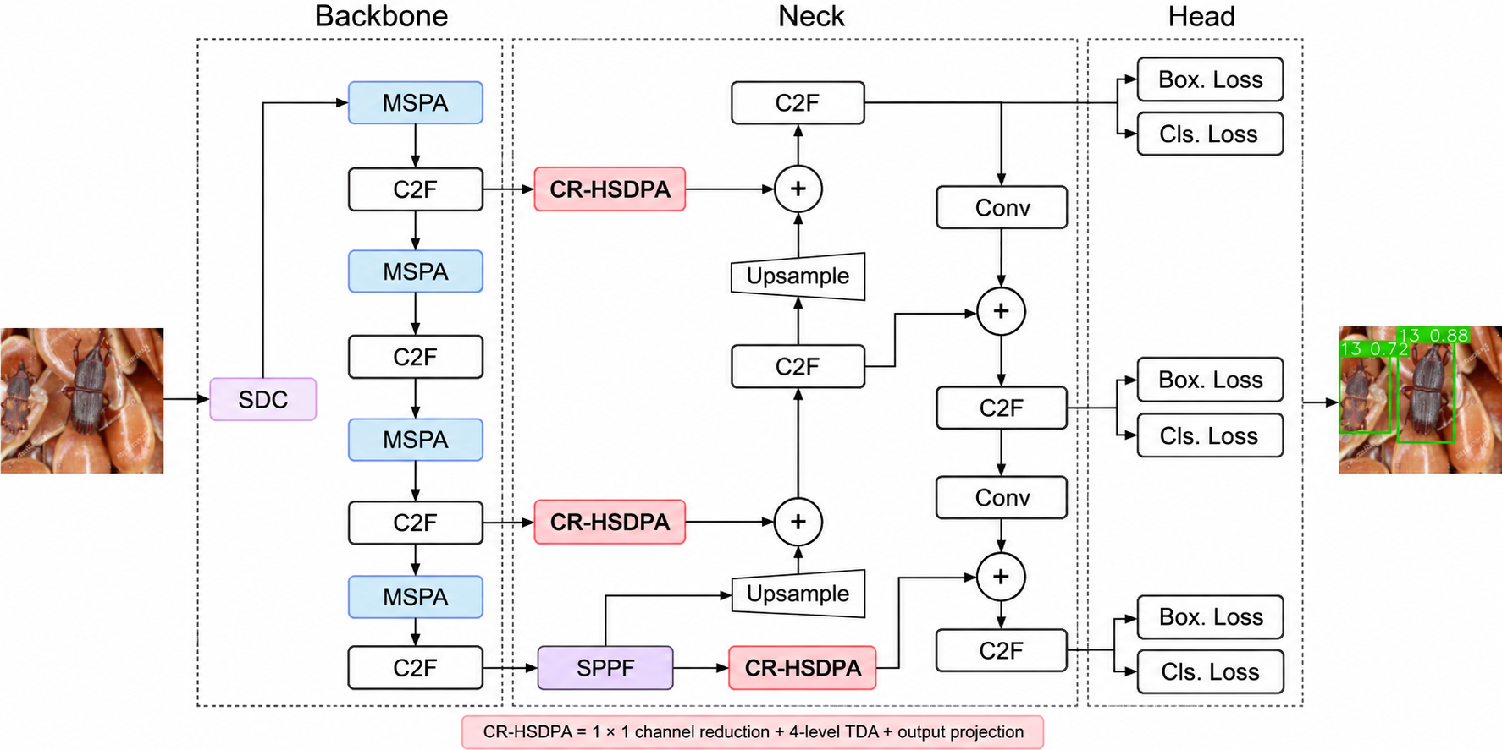
Figure 4. Proposed Modified Attention-PestNet Architecture

Figure 4 shows the modified model retains the original Attention-PestNet backbone, PANet-style neck topology, and detection head, but replaces each HSDPA block in the neck with CR-HSDPA. This preserves the original multi-scale information flow while isolating the effect of channel reduction within the attention module. CR-HSDPA accepts the same incoming feature map and restores the same output channel dimension expected by the surrounding neck layers, allowing it to function as a compatible replacement for the original HSDPA.

Figure 5. Proposed CR-HSDPA Module

CR-HSDPA Module
Figure 5 shows a learnable 1×1 convolution followed by Batch Normalization is introduced before the TDA hierarchy to reduce the incoming feature channels from C to an integer width Cr based on ratio r. The same ratio is applied to all three CR-HSDPA blocks; the resulting widths and a deterministic channel-rounding rule compatible with the TDA implementation will be documented for each block. Unlike fixed channel removal, the projection learns weighted combinations of the original feature channels, allowing the representation to be compressed rather than simply discarding selected channels. After the four TDA levels, the original reduced input and the hierarchical TDA outputs are concatenated, and a 1×1 convolution followed by Batch Normalization restores the required output channel dimension C. A recent agricultural detector, LiteFocus-YOLO, similarly uses learnable 1×1 convolutions with a channel-compression ratio to reduce feature channels before attention-oriented processing and restore the channel dimension afterward [15]. This supports channel reduction as a recent efficiency mechanism, while its effect inside the repeated four-level TDA hierarchy of HSDPA remains untested.

The original four-level TDA hierarchy is retained, but each TDA block processes the reduced Cr-channel representation rather than the full C-channel input. Because the baseline reports a channel-dependent TDA complexity term, reducing C before attention is expected to decrease the computational workload of the hierarchical attention operation, although the added reduction and restoration projections introduce their own cost. The actual effect will therefore be determined using total-model parameters, GFLOPs, model size, and measured forward-pass speed and latency. Excessive channel compression may also remove discriminative information required for pest localization and classification, so the study will measure the detection-performance trade-off relative to the reproduced baseline.

2.4.3 Training Configuration
To remain close to the baseline experimental setup, both IP102 and R2000 will be trained using the same configuration for the reproduced Attention-PestNet and the proposed CR-HSDPA model. Training will use the Ultralytics framework, SGD optimizer, an initial learning rate of 0.01, momentum of 0.9, 640×640 input resolution, and a target of 200 epochs [5]. Training will be performed using an NVIDIA T4 GPU provided through Kaggle. The baseline study used a batch size of 32 on an NVIDIA RTX 4090. If batch size 32 does not fit within the available Kaggle T4 GPU memory, a smaller physical batch size and gradient accumulation will target an effective batch size of 32. The physical batch size, accumulation steps, learning-rate schedule, code revision, pretrained initialization, random seeds, checkpoint-selection rule, and augmentation settings will be recorded and applied consistently to the reproduced baseline and all proposed variants. Automatic mixed precision may also be used consistently for the baseline and proposed model. IP102 and R2000 will be trained and evaluated separately so that the effect of the lightweight modification can be measured independently on each dataset.

  - Ablation Plan
The original HSDPA is the baseline. CR-1.00 adds the pre-attention projection structure without reducing channel width and serves as an architectural control. CR-0.75, CR-0.50, and CR-0.25 test increasing compression. All configurations retain four TDA levels. Model selection will use validation mAP@50:95 and total-model GFLOPs: among variants with at least 10% lower GFLOPs than the reproduced baseline and no more than a one-percentage-point decrease in validation mAP@50:95, the variant with the lowest GFLOPs will be selected. If none meet both criteria, no variant will be described as meeting the target; the measured trade-offs will still be reported. Test results will not influence selection. All variants will also be reported with mAP@50, parameters, model size, FPS, and inference latency.

Table 2. Ablation Plan
Variant | 1×1 CR Bottleneck | 4-Level TDA | Description
Baseline HSDPA | X | ✓ | Original Attention-PestNet HSDPA without a pre-attention channel-reduction bottleneck. The four TDA levels operate on the full channel dimension C.
+CR-1.00 | ✓ | ✓ | Adds the pre-attention 1×1 bottleneck but retains the full channel dimension. Serves as a control for the added bottleneck structure.
+CR-0.75 | ✓ | ✓ | Reduces the feature channels to $0.75C$ before the four TDA levels to evaluate mild channel compression.
+CR-0.50 | ✓ | ✓ | Reduces the feature channels to $0.50C$ before the four TDA levels to evaluate moderate channel compression.
+CR-0.25 | ✓ | ✓ | Reduces the feature channels to $0.25C$ before the four TDA levels to evaluate aggressive channel compression.

Model Evaluation
The reproduced Attention-PestNet and proposed CR-HSDPA model will be evaluated separately on IP102 and R2000. Detection performance will be measured using mAP@50 and mAP@50:95. Computational efficiency will be evaluated using parameter count, GFLOPs, model size, frames per second (FPS), and inference latency. All hardware-dependent measurements will be collected in the same Kaggle NVIDIA T4 GPU environment. For forward-pass FPS and latency, inference will use batch size one, 640×640 inputs, FP32 precision, 20 warmup runs, and 200 timed runs per model. CUDA operations will be synchronized before and after each timed run. The timing will exclude image loading, preprocessing, and non-maximum suppression; this boundary and the software environment will be reported with the results.

mAP@50
mAP@50 measures mean Average Precision across all pest classes at an Intersection over Union (IoU) threshold of 0.50. AP represents the area under the precision-recall curve for each class, while C denotes the number of evaluated pest classes.

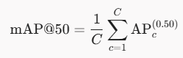

mAP@50:95
mAP@50:95 provides a stricter measure of detection and localization quality by averaging AP across IoU thresholds from 0.50 to 0.95 in increments of 0.05.

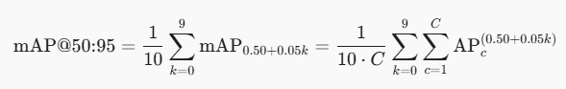

Number of Parameters
The number of parameters represents the total learned and stored parameters in the network. A lower parameter count indicates a more compact architecture and is important for assessing whether CR-HSDPA reduces model complexity.

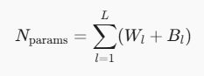

    - GFLOPs
GFLOPs estimate the number of floating-point operations required for one forward pass. For a fair comparison, GFLOPs will be measured using the same 640×640 input resolution for both models.

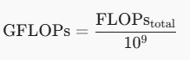

    - Frames Per Second
Frames per second (FPS) measures inference throughput, where N is the number of images processed and T is the total inference time in seconds. Higher FPS indicates faster inference.

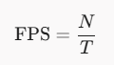

    - Inference Latency
Inference latency measures the average time required to process one image. T is the total inference time in seconds and N is the number of processed images. The value is converted to milliseconds per image.

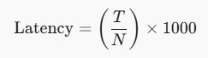

    - Model Size
Model size measures the storage required by the saved model file and provides a practical indicator of deployment cost. The file size will be reported in megabytes (MB).

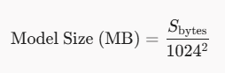

Model Assessment
Model assessment will compare the reproduced Attention-PestNet against the final CR-HSDPA configuration and its ablation variants on both IP102 and R2000. The analysis will emphasize the trade-off between detection performance and computational efficiency rather than detection accuracy alone. The study will examine whether channel reduction within HSDPA produces consistent computational benefits across the broader IP102 benchmark and the rice-pest-focused R2000 benchmark. A CR-HSDPA configuration may still be considered useful if it produces a small change in mAP while providing a meaningful reduction in parameters, GFLOPs, model size, or inference latency, or an improvement in FPS. All trade-offs will be reported quantitatively rather than assumed beforehand.

Ethical Consideration
This study will observe applicable ethical, copyright, and data-handling requirements throughout the conduct of the research. The IP102 and R2000 datasets will be obtained from their publicly accessible repositories and used strictly for academic and experimental purposes in accordance with the conditions provided by their respective sources. As the study relies entirely on existing public datasets and does not collect information from human participants, no informed consent process is necessary. All downloaded dataset files will be handled only by the research team and used exclusively for training, validation, testing, and comparing the original Attention-PestNet with the proposed CR-HSDPA model. Generative AI tools may be used as support for tasks such as research assistance, technical programming, formatting, and writing assistance. However, the researchers will remain responsible for the study design, implementation, experimentation, analysis, interpretation, and verification of all results.

References
[1] Food and Agriculture Organization of the United Nations. (2019, March 4). New standards to curb the global spread of plant pests and diseases. https://www.fao.org/newsroom/detail/New-standards-to-curb-the-global-spread-of-plant-pests-and-diseases/en

[2] Philippine Statistics Authority. (n.d.). Palay situation report, October to December 2025 and January to December 2025. https://psa.gov.ph/statistics/crops/palay-situation-report/node/1684082355

[3] World Bank. (2025). Technical assistance for sustainable agricultural transformation in the Philippines (P509767). https://documents.worldbank.org/en/publication/documents-reports/documentdetail/099070725060550299

[4] Department of Agriculture–Philippine Rural Development Project. (2024, September 9). The digitalization of Philippine agriculture: How a World Bank-funded project is making headways. https://prdp.da.gov.ph/the-digitalization-of-philippine-agriculture-how-a-world-bank-funded-project-is-making-headways/

[5] Doan, V. T., Le, H. T., Pham, T. T. T., & Dai, H.-J. (2026). Attention-PestNet: Hierarchical scaled dot-product attention for insect pest detection. Plant Methods, 22, Article 9. https://doi.org/10.1186/s13007-025-01489-z

[6] Philippine Statistics Authority. (2024, December 27). 2022 Census of Agriculture and Fisheries: Agricultural farm and parcel characteristics (Press Release No. 2024-391). https://psa.gov.ph/sites/default/files/afcd/1_2022%20CAF_Press%20Release_Agriculture%20Sector_ONS_AFCDrev122324-signed_rev2.pdf

[7] DA–Philippine Rice Research Institute. (2026, January 23). PhilRice warns of major rice pest threats in early 2026. https://www.philrice.gov.ph/philrice-warns-of-major-rice-pest-threats-in-early-2026/

[8] Food and Agriculture Organization of the United Nations, & International Plant Protection Convention. (2021). Scientific review of the impact of climate change on plant pests: A global challenge to prevent and mitigate plant pest risks in agriculture, forestry and ecosystems. https://reliefweb.int/report/world/scientific-review-impact-climate-change-plant-pests-global-challenge-prevent-and

[9] International Rice Research Institute. (2025, October 16). DA-BPI, DA-PhilRice, and IRRI strengthen climate-smart pest management in rice in the Philippines. https://www.irri.org/news-and-events/news/da-bpi-da-philrice-and-irri-strengthen-climate-smart-pest-management-rice

[10] Shoaib, M., Sadeghi-Niaraki, A., Ali, F., Hussain, I., & Khalid, S. (2025). Leveraging deep learning for plant disease and pest detection: A comprehensive review and future directions. Frontiers in Plant Science, 16, Article 1538163. https://doi.org/10.3389/fpls.2025.1538163

[11] Ejaz, M. H., Bilal, M., Habib, U., Attique, M., & Chung, T.-S. (2025). Crop pest classification using deep learning techniques: A review. arXiv. https://arxiv.org/abs/2507.01494

[12] Zhang, L., Zhao, C., Feng, Y., & Li, D. (2023). Pests identification of IP102 by YOLOv5 embedded with the novel lightweight module. Agronomy, 13(6), Article 1583. https://doi.org/10.3390/agronomy13061583

[13] Dong, Q., Sun, L., Han, T., Cai, M., & Gao, C. (2024). PestLite: A novel YOLO-based deep learning technique for crop pest detection. Agriculture, 14(2), Article 228. https://doi.org/10.3390/agriculture14020228

[14] Liu, X., Peng, H., Zheng, N., Yang, Y., Hu, H., & Yuan, Y. (2023). EfficientViT: Memory efficient vision transformer with cascaded group attention. arXiv. https://doi.org/10.48550/arXiv.2305.07027

[15] Wang, H., Hu, J., Ji, Y., Peng, C., Bao, Y., Zhu, H., Zhu, C., Chen, M., Mu, Y., & Guo, H. (2025). LiteFocus-YOLO: An efficient network for identifying dense tassels in field environments. Agriculture, 15(19), Article 2036. https://doi.org/10.3390/agriculture15192036

[16] Yang, X., He, Q., Xie, X., & Dong, M. (2025). YOLO-RP: A lightweight and efficient detection method for small rice pests in complex field environments. Symmetry, 17(10), Article 1598. https://doi.org/10.3390/sym17101598

[17] United Nations Department of Economic and Social Affairs. (n.d.). Goal 2: End hunger, achieve food security and improved nutrition and promote sustainable agriculture. Sustainable Development Goals. https://sdgs.un.org/goals/goal2

[18] Wu, X., Zhan, C., Lai, Y.-K., Cheng, M.-M., & Yang, J. (2019). IP102: A large-scale benchmark dataset for insect pest recognition. In Proceedings of the IEEE/CVF Conference on Computer Vision and Pattern Recognition (pp. 8787–8796). https://doi.org/10.1109/CVPR.2019.00899

[19] Zheng, Y., Zheng, W., & Du, X. (2024). A lightweight rice pest detection algorithm based on improved YOLOv8. Scientific Reports, 14, Article 29888. https://doi.org/10.1038/s41598-024-81587-5

[20] Zheng, Y., Zheng, W., & Du, X. (2025). Paddy-YOLO: An accurate method for rice pest detection. Computers and Electronics in Agriculture, 238, Article 110777. https://doi.org/10.1016/j.compag.2025.110777

[21] Xiang, Q., Huang, X., Huang, Z., Chen, X., Cheng, J., & Tang, X. (2023). Yolo-Pest: An insect pest object detection algorithm via CAC3 module. Sensors, 23(6), Article 3221. https://doi.org/10.3390/s23063221

[22] Wang, X., Zhang, S., & Zhang, T. (2024). Crop insect pest detection based on dilated multi-scale attention U-Net. Plant Methods, 20, Article 34. https://doi.org/10.1186/s13007-024-01163-w

